

**Module 6:**

**System Hacking**

**Group 3**

**Team Members:**

1. Ali Muntazir 2023098
2. Muhammad Ismail 2023453
3. Abdullah Ahtasham 2023033

**Course: CY201 – Cyber Security Principles and Concepts**

**Instructor: Mr. Abdullah Bin Zarshaid**

**Date of Submission: 14th May 2025, Wednesday**

**Objective of the Module:**

This module focuses on the techniques attackers use to gain unauthorized access to computer systems. It explores methods like password cracking, privilege escalation, and backdoor installation. The goal is to understand how system hacking works in real-world scenarios so that effective defensive strategies can be developed. By simulating attacks in a controlled environment, learners gain hands-on experience in identifying and mitigating threats. The module emphasizes the importance of proactive defense in protecting critical systems.

**Environment Setup:**

OS used:

1. Windows 11
2. Parrot OS
3. Windows Server 2022

Virtualization Tool used: VirtualBox

Lab 1 (Gain Access to the System):

Task 2: Audit System Passwords Using L0pht Crack

Attacker OS: Windows 11

Target OS: Windows Server 2022

Network Setting: NAT and Host only (Two Adapter used)

Tool Used: L0pht Crack

Task 3: Finding Vulnerabilities on Exploit Sites

Attacker OS: Windows 11

Target OS: N/A

Network Setting: NAT

Tool Used: Website used Exploit DB

Task 5: Gain Access to Remote System

Attacker OS: Parrot OS

Target OS: Windows 11

Network Setting: NAT and Host only (Two Adapter used)

Tool Used: Armitage and Nmap

Lab 2 (Privilege Escalation):

Unable to be performed as it required Spyware tools that were unavailable to us. The lab was not performed and hence we moved forth with the other labs

Lab 3 (Maintain Remote Access and Hide Malicious Activities)

Task 3: Hiding Files using NTFS Stream

Attack OS: Windows Server 2022

Target OS: N/A

Network Setting: NAT

Tool Used: Command Prompt

Task 5: Image Steganography using OpenStego

Attack OS: Windows 11 or Windows Server

Target OS: Any system sent

Network Setting: NAT

Tool Used: OpenStego

Lab 4 (Clear Logs to Hide the Evidence of Compromisation)

Task 1: View Enable and Clear Audit Policing Using Audit Poll

Attack OS: Windows 11

Target OS: N/A

Network Setting: NAT

Tool Used: Command Prompt

Task 4: Hiding Artifacts in Windows and Linux Machine

Attack OS: Windows 11 and Parrot OS

Target OS: N/A

Network Setting: NAT

Tool Used: Command Prompt and MATE Terminal

**Tool Used:**

1. Armitage: Attack Management Tool to help visualize targets and perform attack easily, mainly used in pen testing
2. Command Prompt: It allows users to execute commands, run scripts, and manage files and directories
3. MATE Terminal: It provides a command-line interface, allowing users to interact with the operating system through text-based commands.
4. L0pht Crack: Password Auditing and Recovery tool, for Windows Systems to test and extract passwords/hashes.
5. Nmap: Powerful command line tool, for network discovery and security auditing.

**Commands Used:**

1. Cd C:\magic (opens magic folder in C folder in cmd)
2. notepad read.txt (creates a .txt file by the name of read)
3. dir (shows all data present in the opened folder)
4. type c:\magic\calc.exe > c:\magic\read.txt:calc.exe (hides the calc.exe inside read.txt)
5. mklink backdoor.exe read.txt:calc.exe (to create symbiosis link between backdoor.exe and read.txt so that when backdoor.exe is executed, it opens the hidden file in read.txt)

**Task Performance:**

**Lab 1:**

**Task 2:**

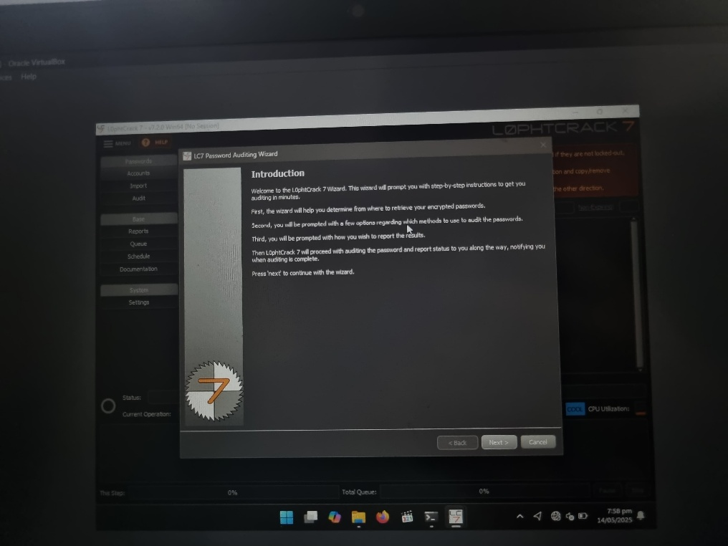

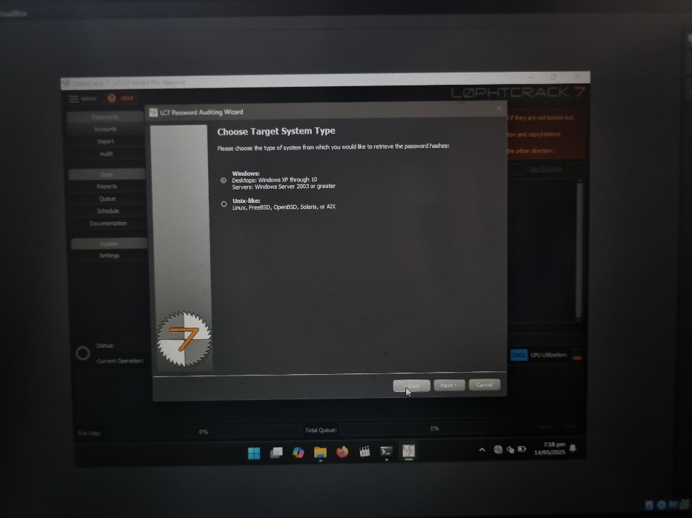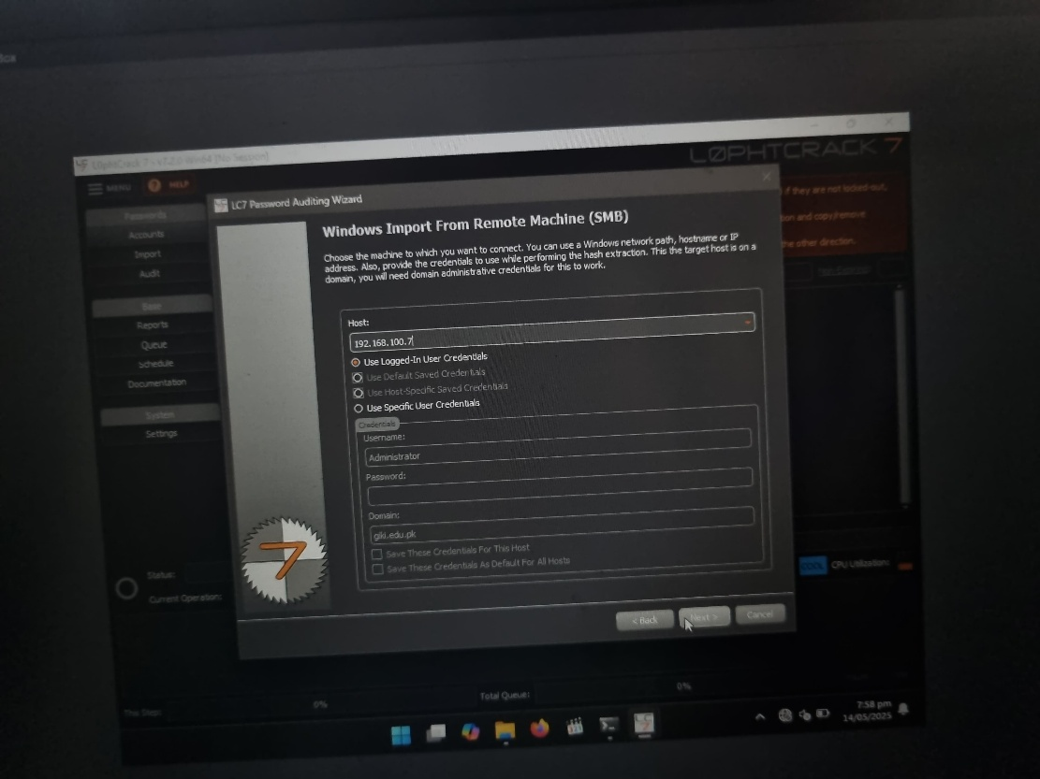

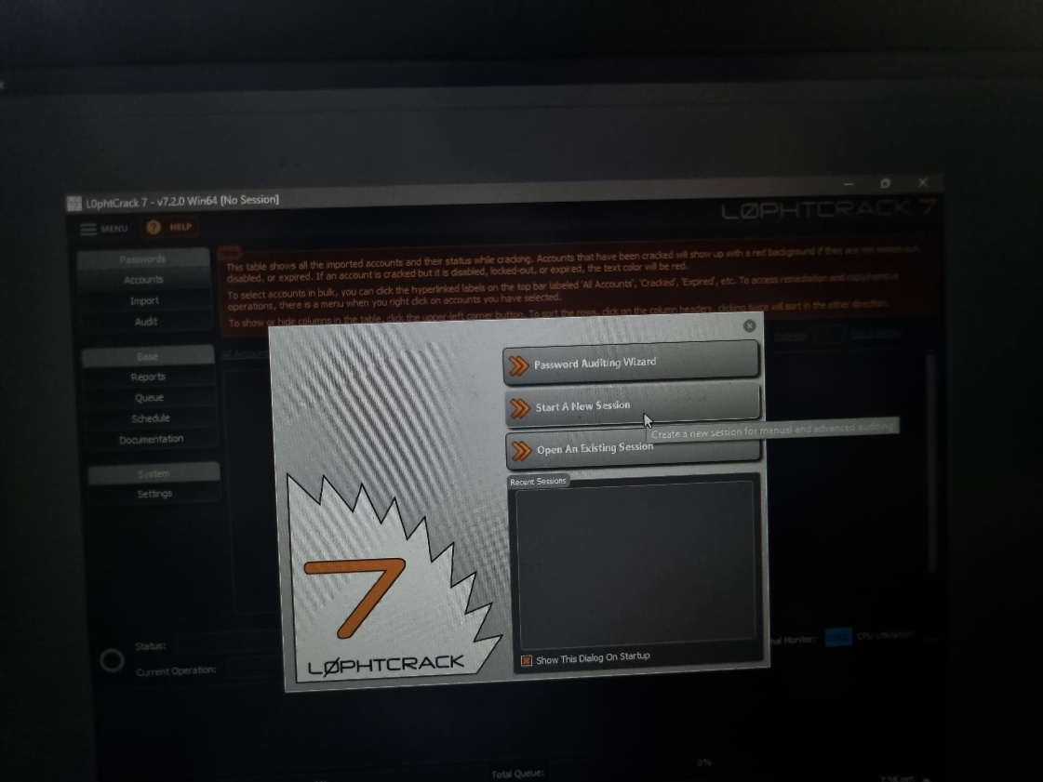

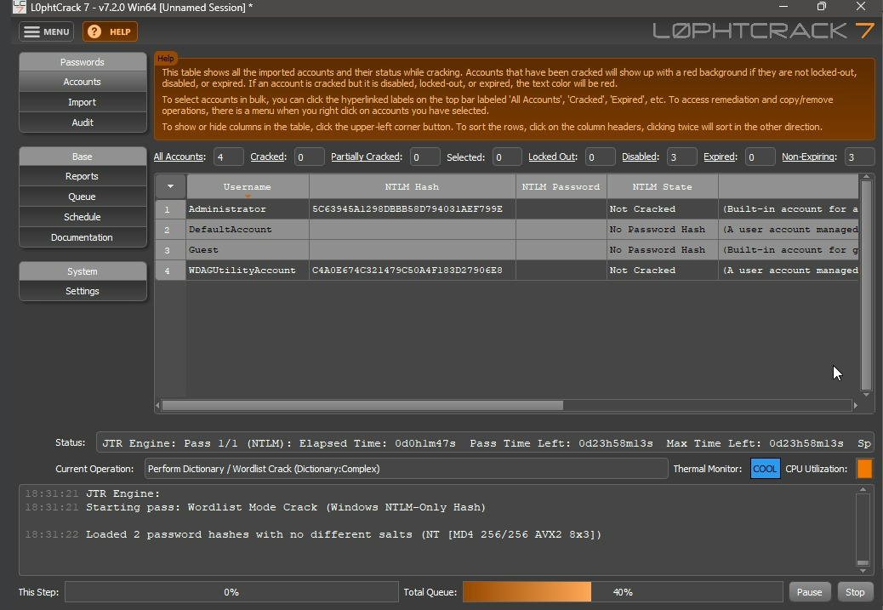

**Task 3:**

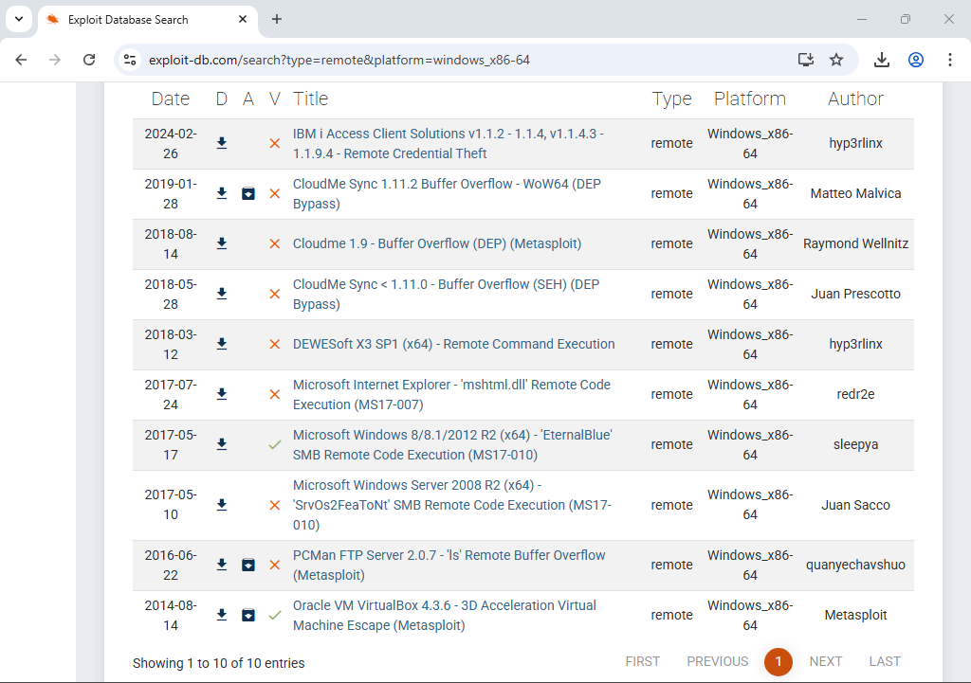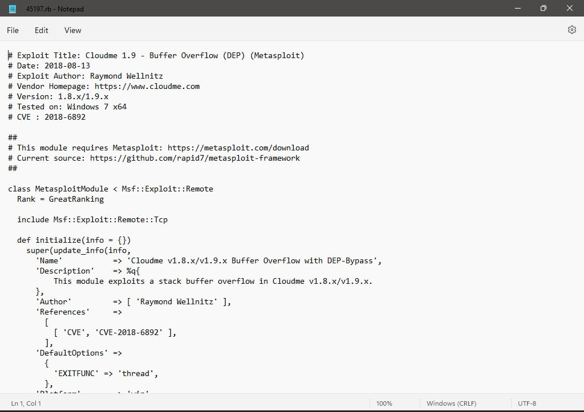

**Task 5:**

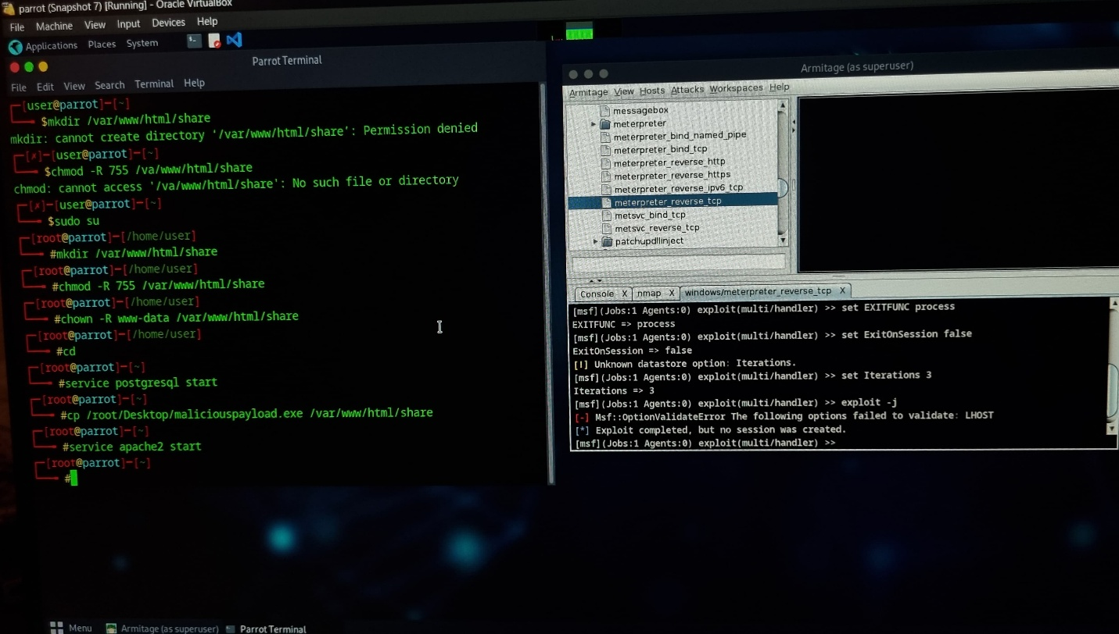

**Lab 3:**

**Task 3:**

1. On the server VM check if the C drive is in NTFS format:

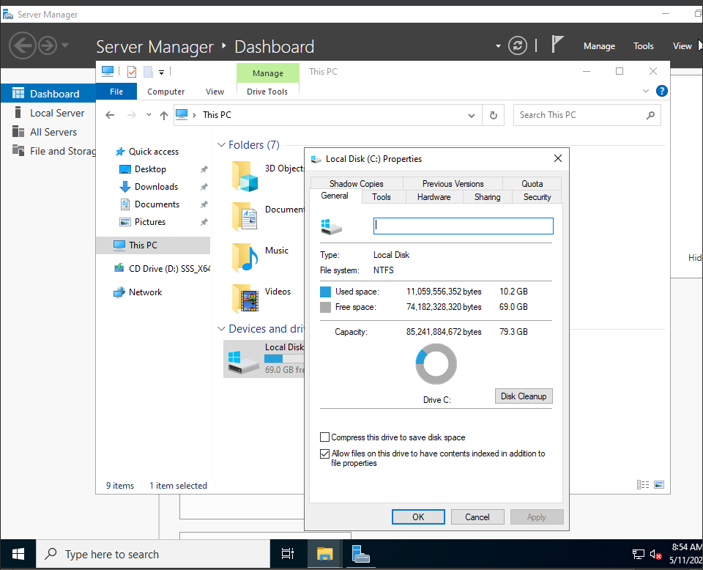

1. Make magic folder in C drive and copy cal.exe from C:\Windows\System32 and paste in magic folder.:

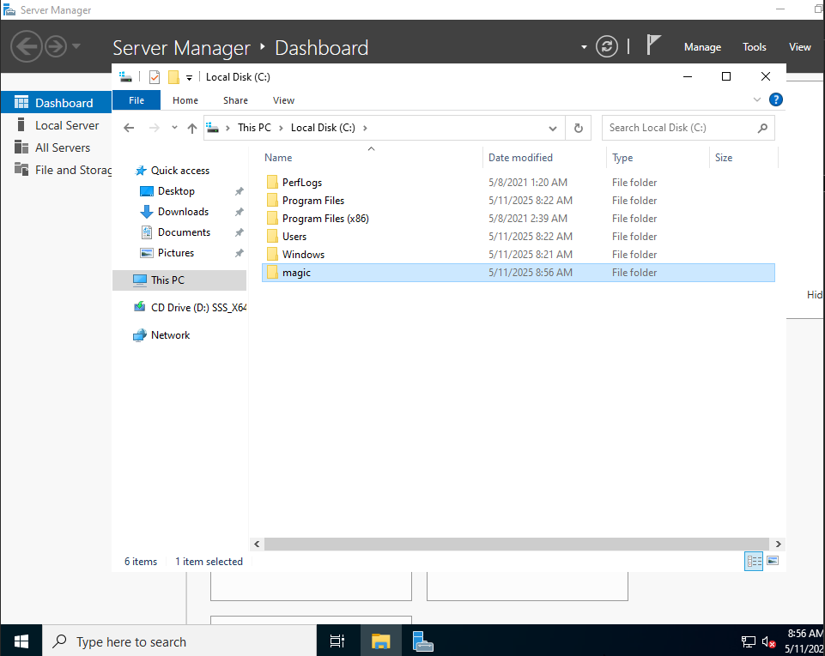

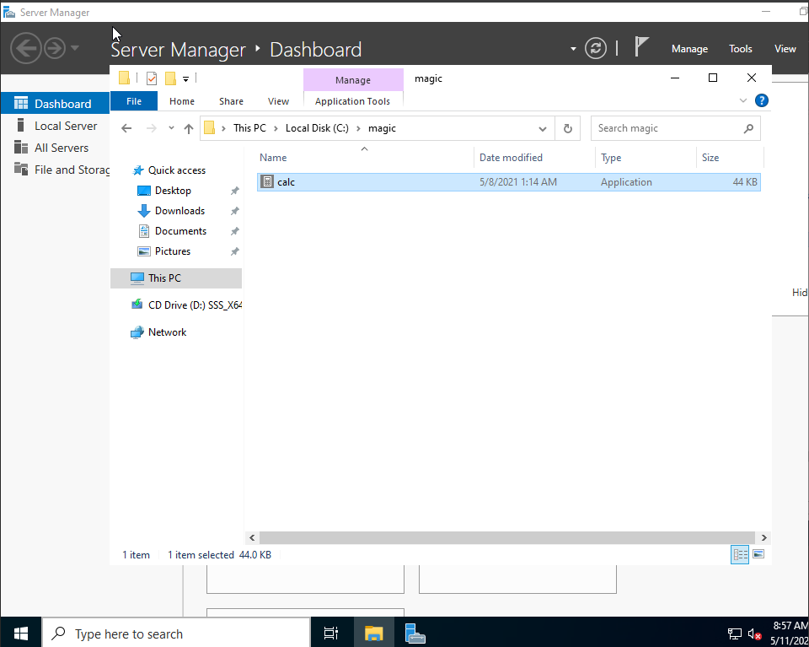

1. Open CMD (Command Prompt) and open the magic folder on it.
2. Create new read.txt file there.

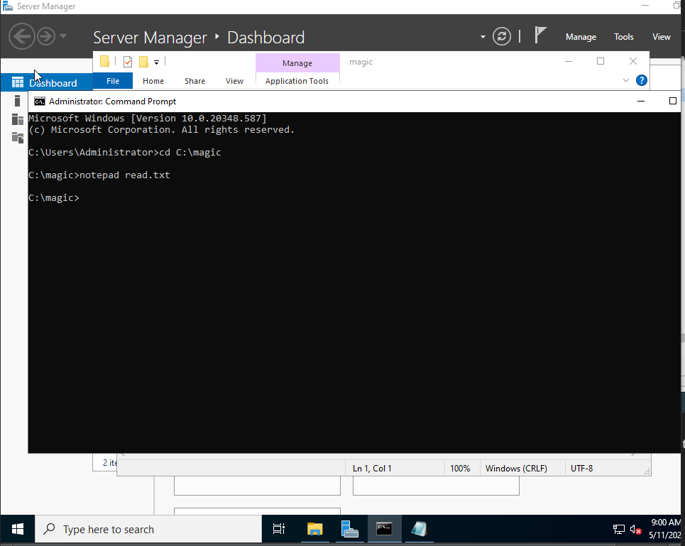

1. Write in notepad (e.g Hello world) and save the file. Close the file after this.

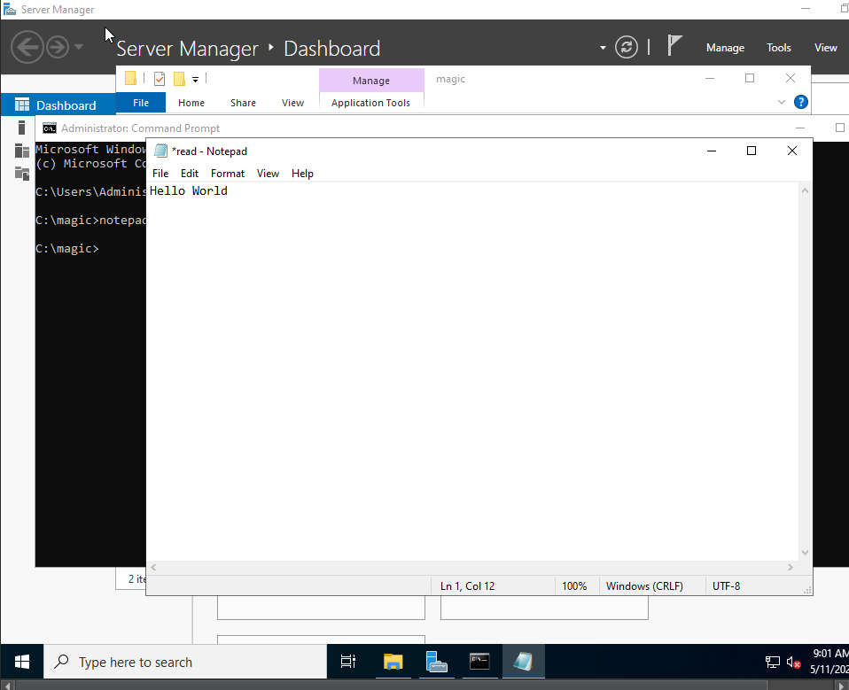

1. Type dir in CMD, note the size of read.txt:

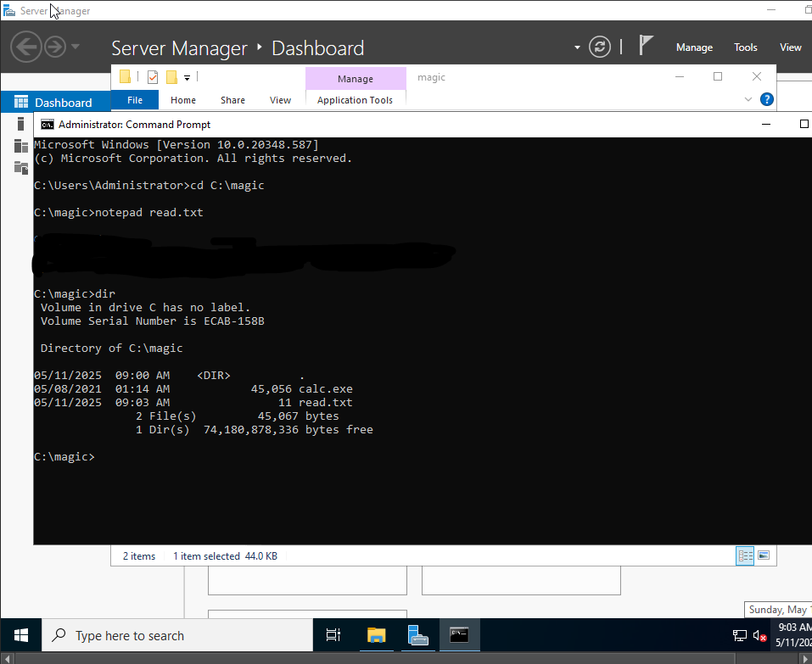

1. Now enter: ‘type c:\magic\calc.exe > c:\magic\read.txt:calc.exe’.
2. Type dir in CMD and you shall notice the file size has not changed:

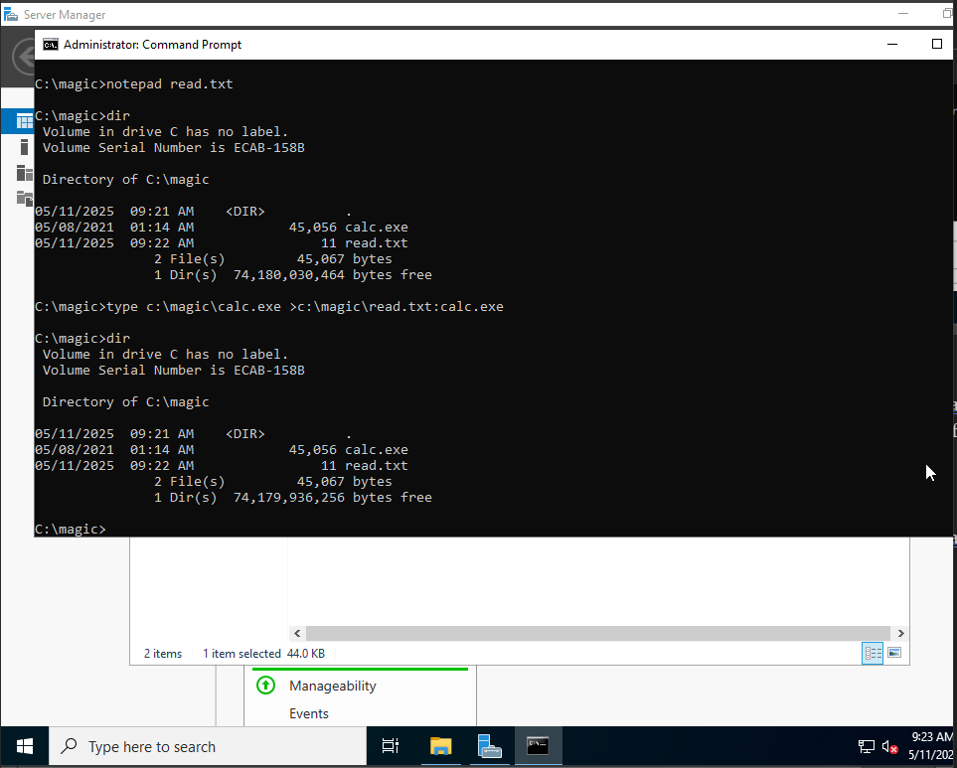

1. Delete calc.exe from magic.

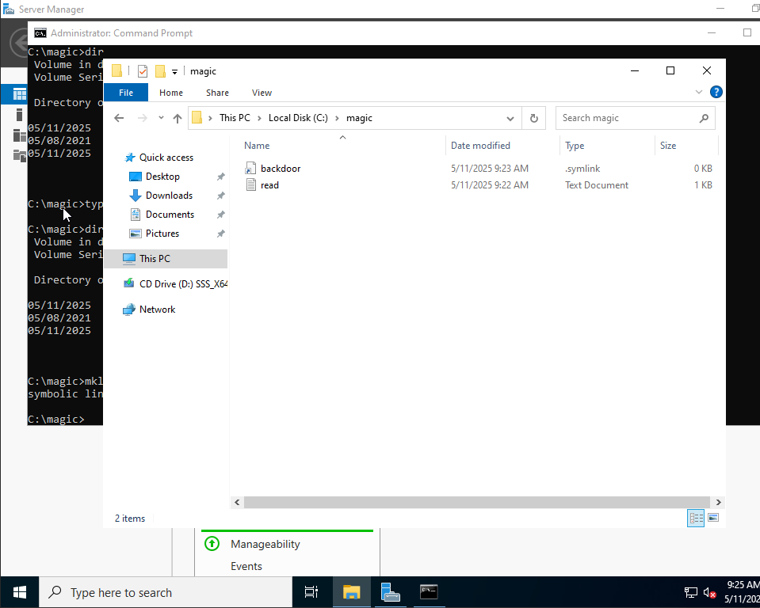

1. Now type: mklink backdoor.exe read.txt:calc.exe and then press enter

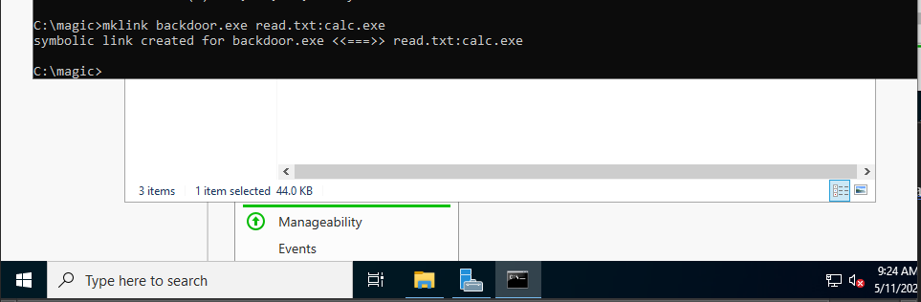

1. Now type backdoor.exe and press enter. The calc.exe should be executed.

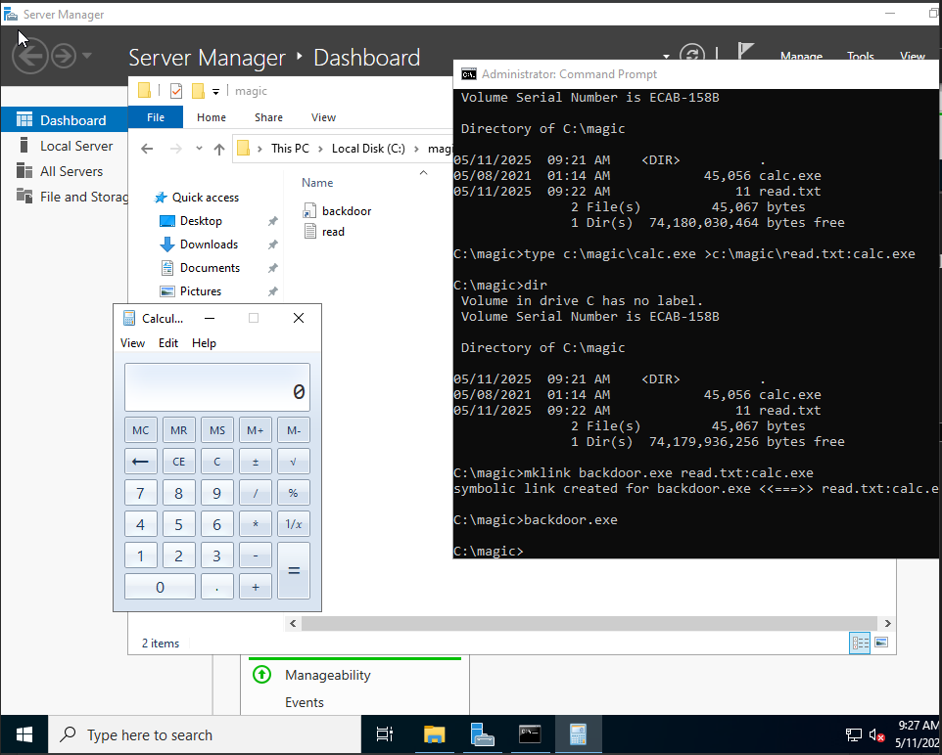

This was done on one system only, but an attacker can attempt to hide their malicious files on your drive and hide them with some real data so that there is no suspicion. This way they can remotely execute the program whenever they wish.

**Task 5:**

1. Open OpenStego on the Windows Server VM

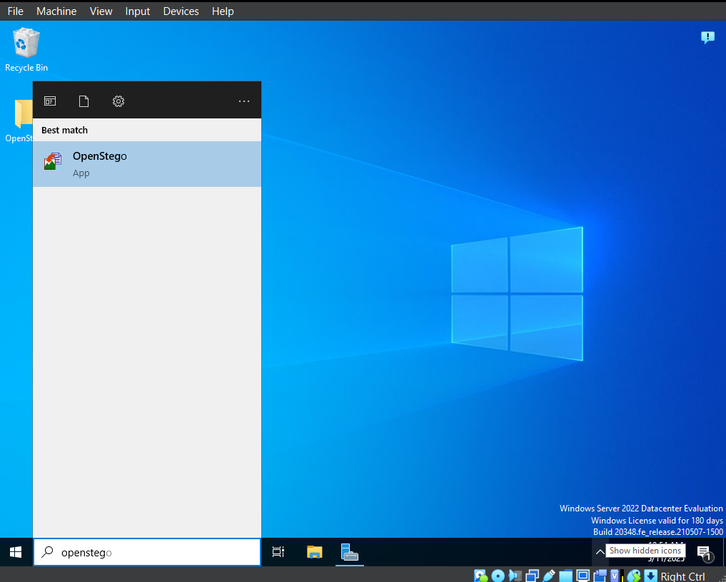

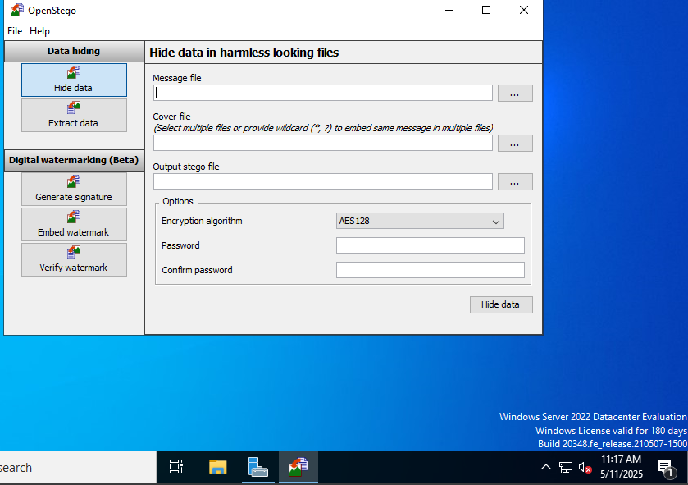

1. Open the ellipsis button and select the text document from the OpenStego folder on desktop on vm

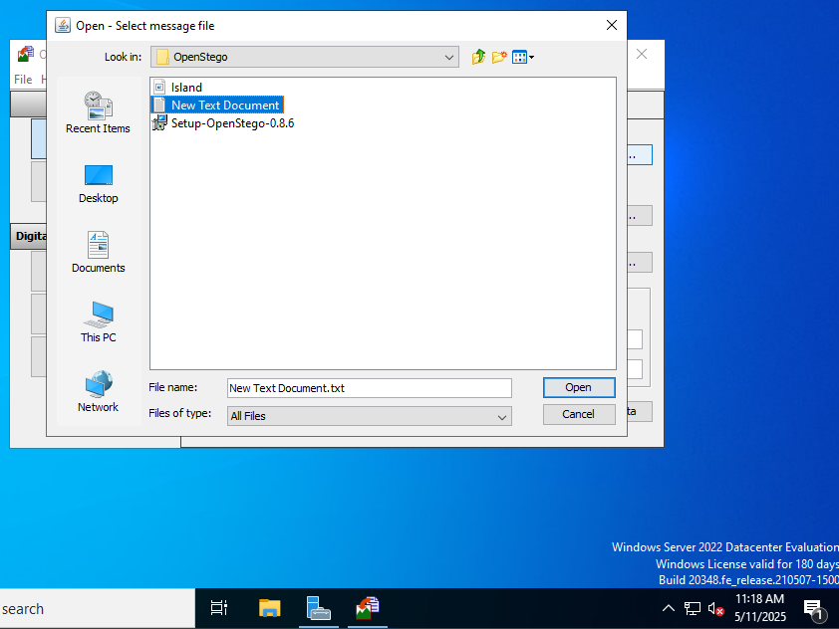

1. Open the photo in the cover file location using the ellipsis button

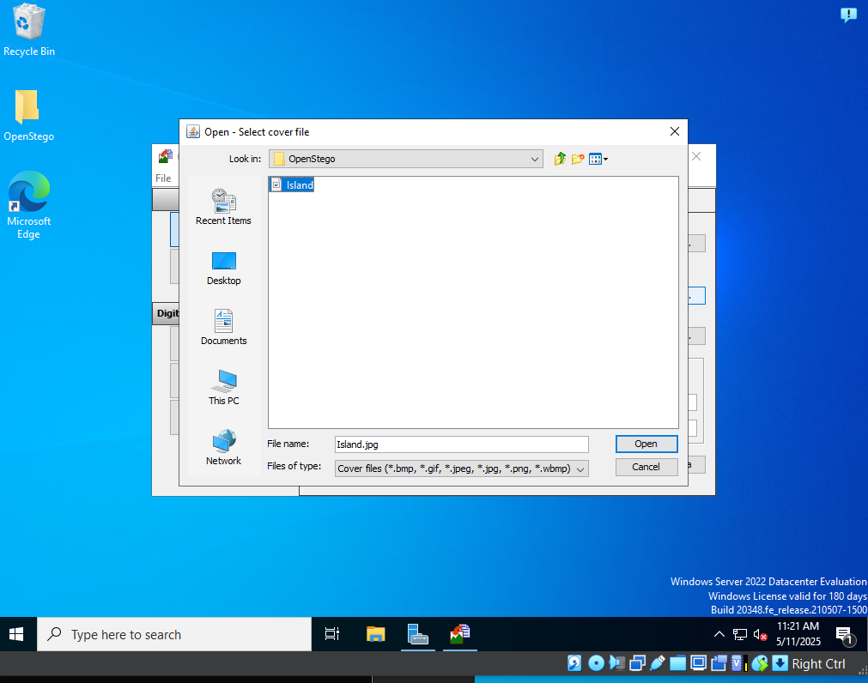

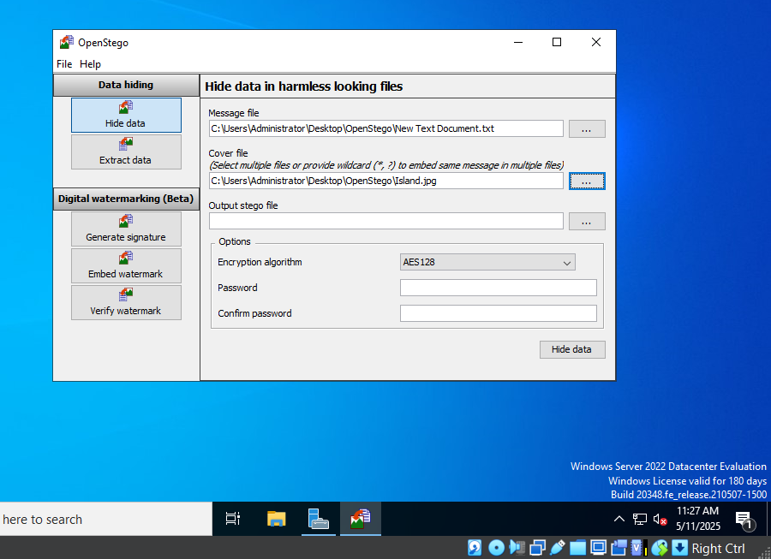

1. Click the ellipsis button to the output file and put the output location of the file and name (in this case the desktop)

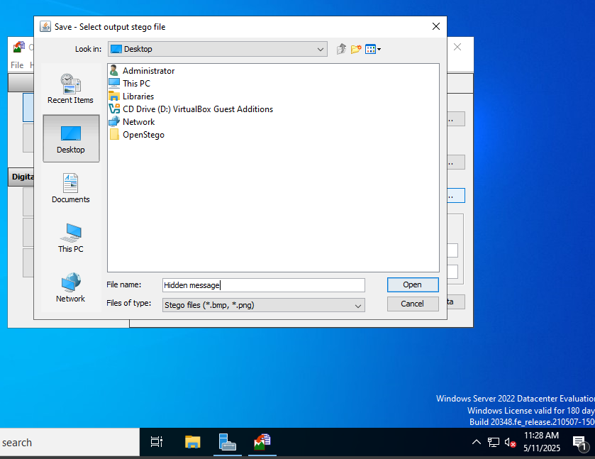

1. Click hide data and you will get the success prompt

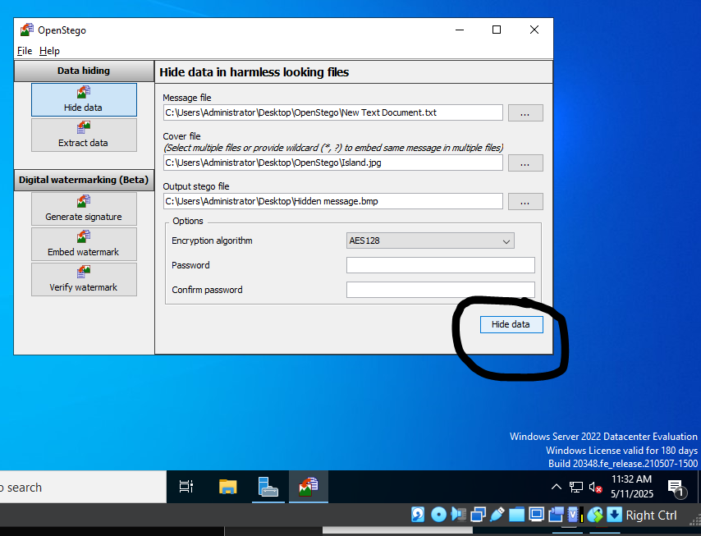

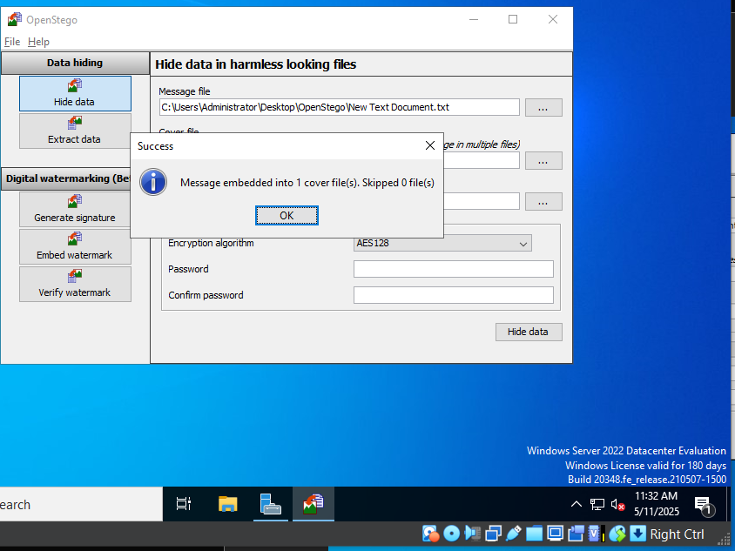

1. Open the image, you will see that it is the same image but the contents of the file (doc) are hidden

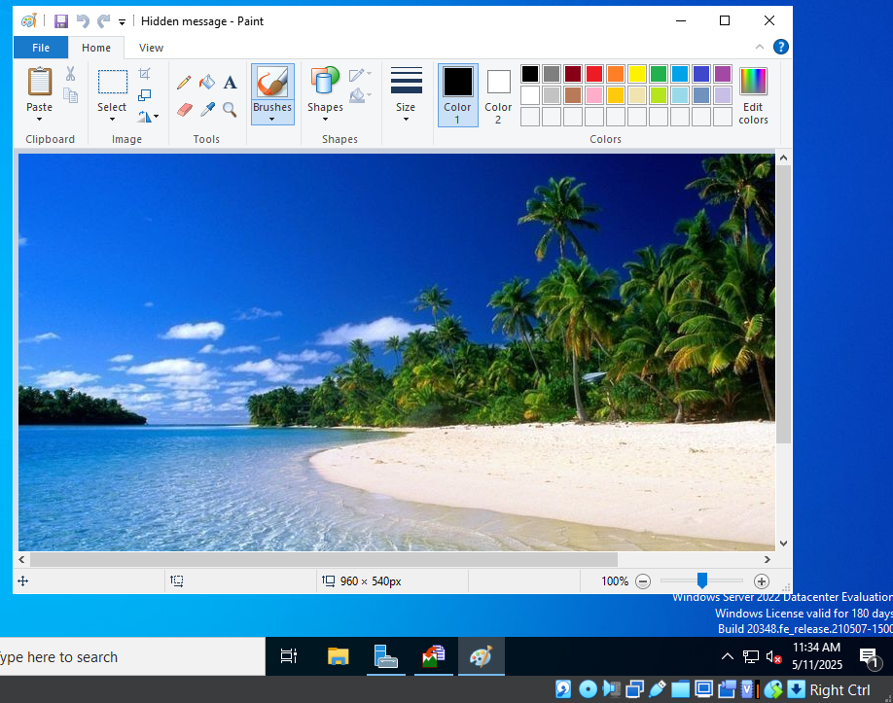

1. Use the extract function in OpenStego to find the contents of the file

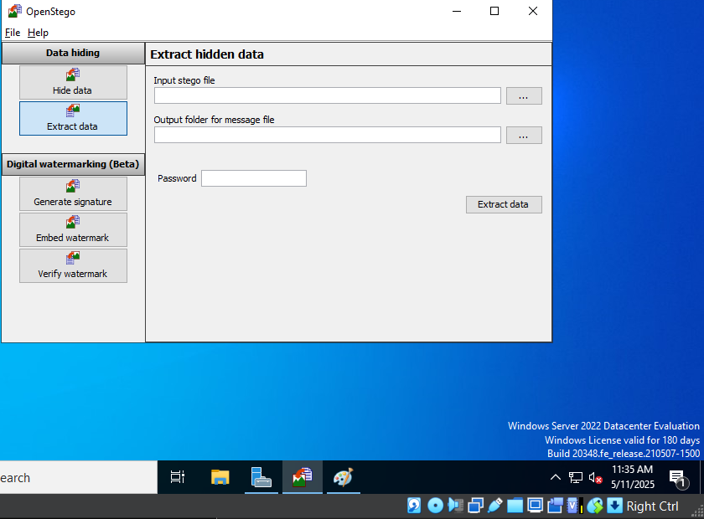

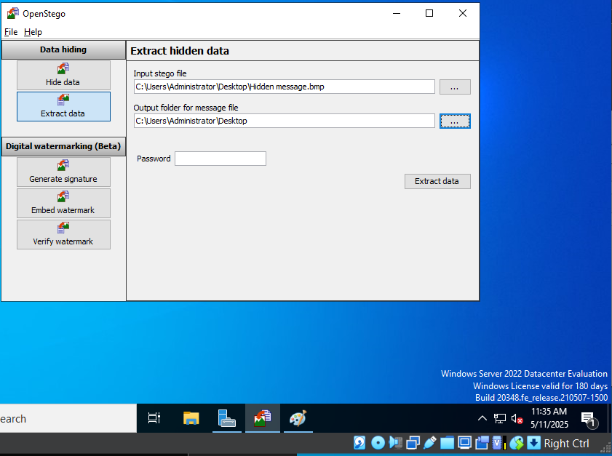

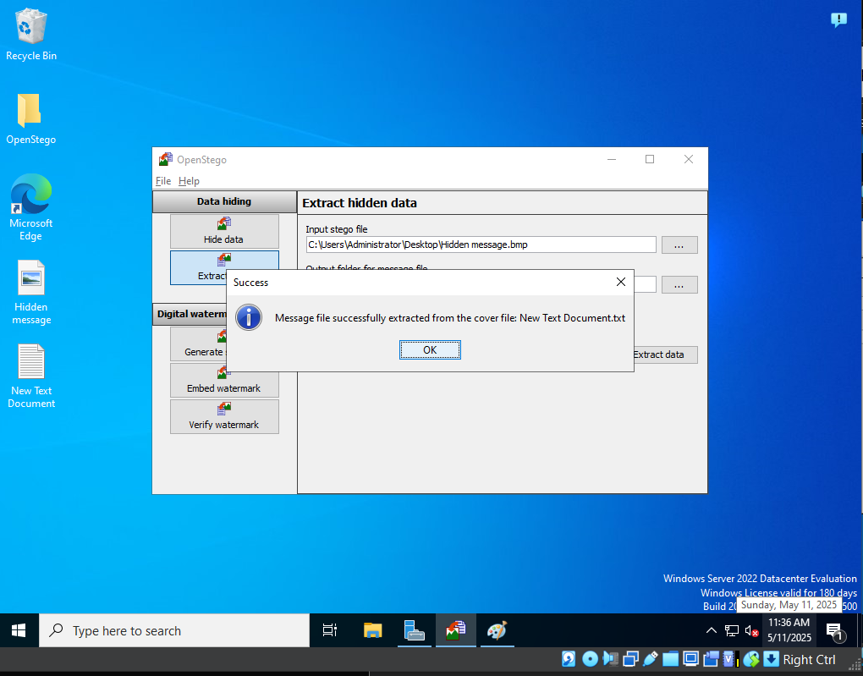

**Lab 4:**

**Task 2:**

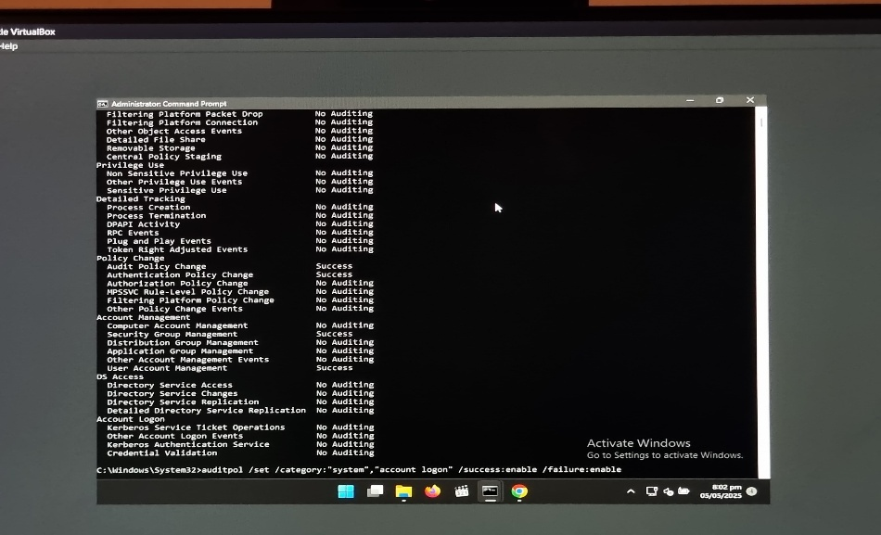

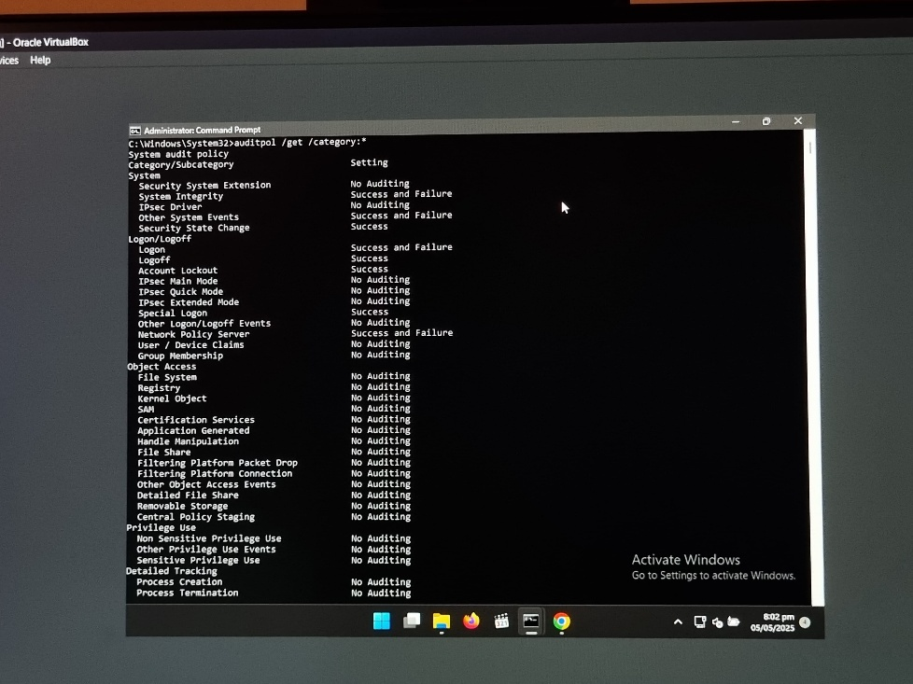 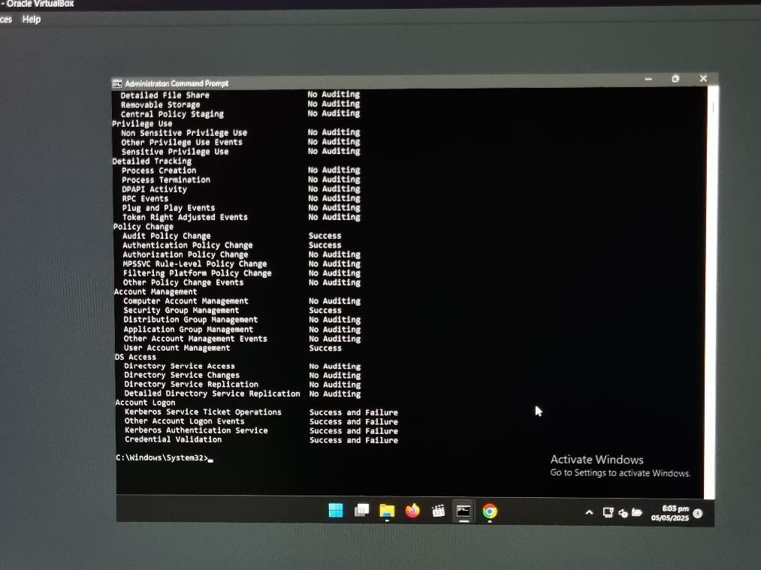

**Task 5:**

**Windows:**

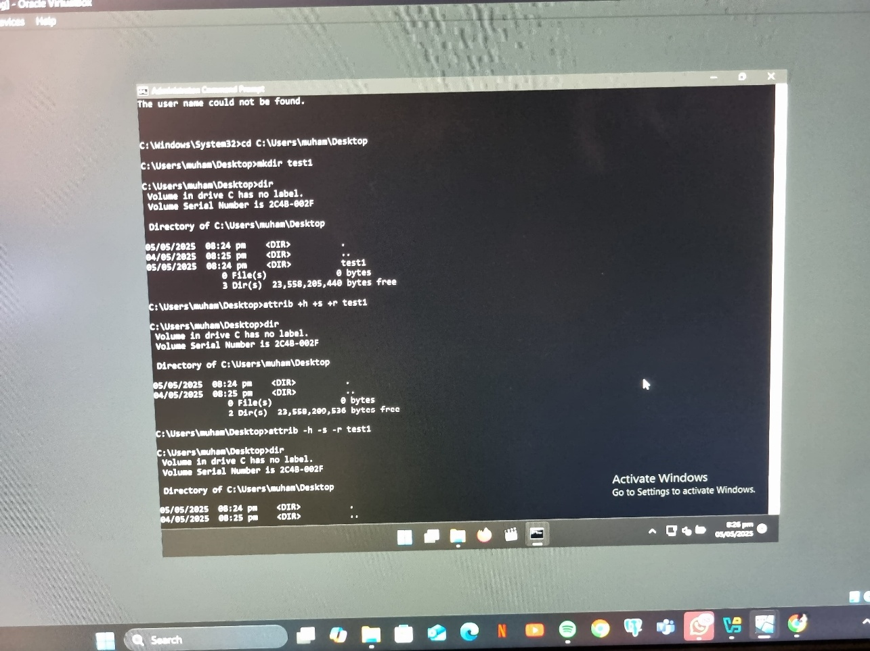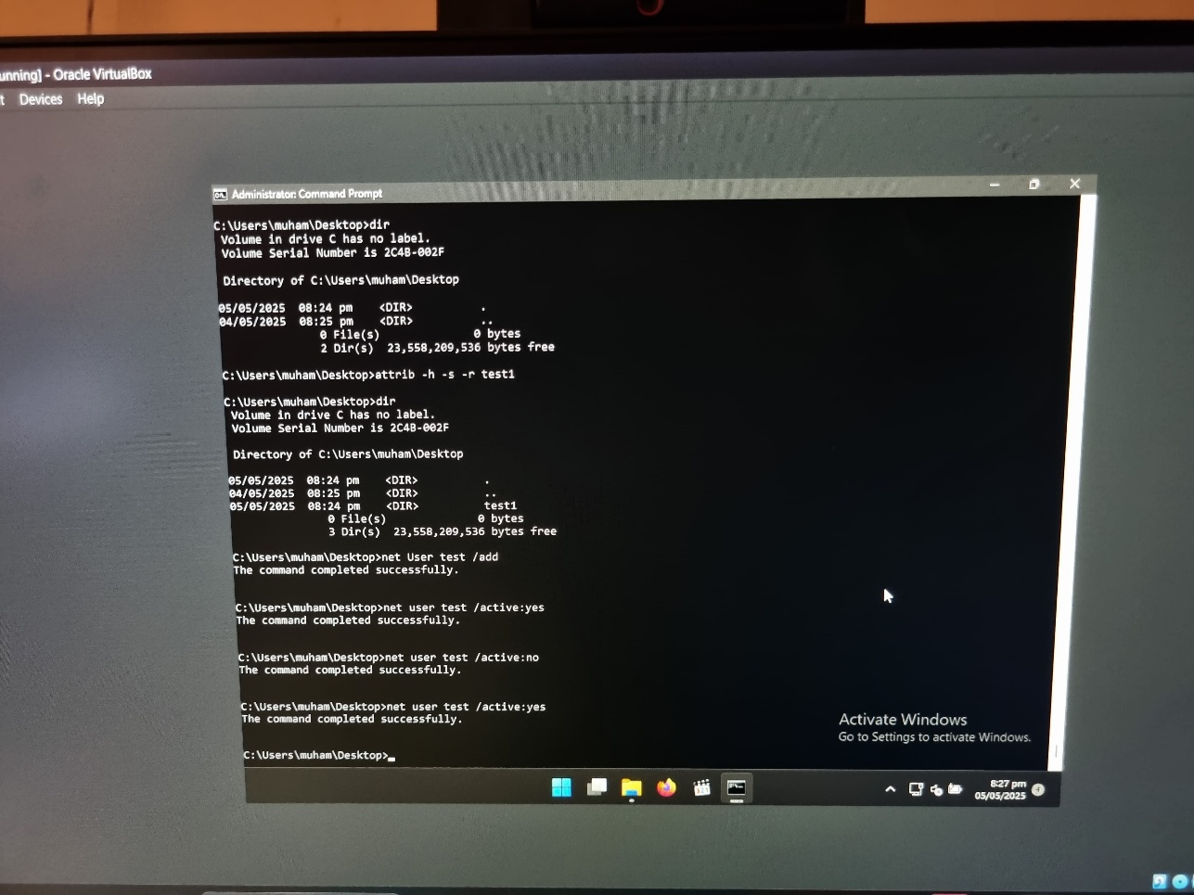

**Parrot OS:**

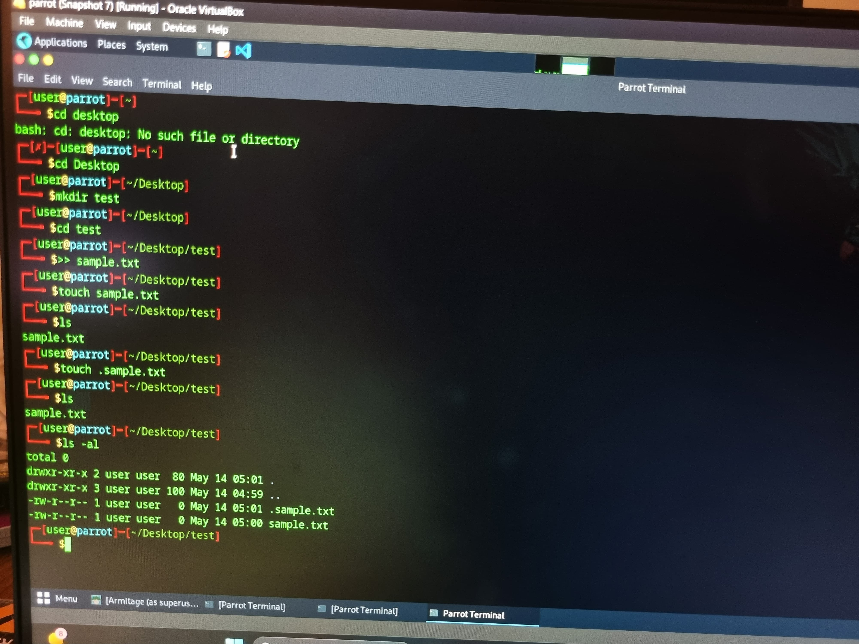

**Error Faced:**

1. Could not ping vms together

**Solution:**

2 adapters used, 1st set as NAT and 2nd was set as Host Only

1. John The Ripper was not being accessed on the Ubuntu OS.

**Temp Solution:**

Parrot OS was used to download John the ripper but with all files availabe, it was still not being accessed.

**Learing Outcomes:**

We gained hands-on experience by using the CeH tools and commands to learn about System Hacking. OpenStego taught us how this tool could be used for stegography. We also learned how remote access other systems and exploit the vulnerablities present so that we can gain access other systems whilst being based some place else. We also how to exploit vulnerabilities in sites so that we can gain access to them and as well as learning how to hide malicious files so that we can execute them remotely.

In real world experience we could use these new found tools and commands to gain access to other systems and then carry out suspicious activites or hide such files. We could also make sure to safeguard ourselves from such vulnerablities and make sure that we do not fall victim to such tactics.

There were a lot of issues with some task as we required tools and due to network issues from where we were based we could not use the tools.

Jack the ripper was very difficult to be configured and we were unable to carry out the task required.